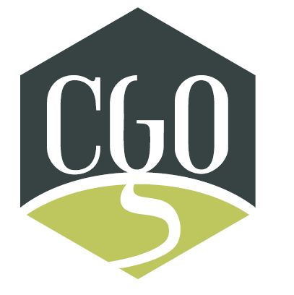
Community Governed
Organizations

PO Box 48044, Mill cove PO
965 Bedford Highway
Bedford, NS B4A 3Z2
E-mail: cgons.info@gmail.com
www.cgons.ca

Welcome to the CGO Website!

Want to join our team of dedicated individuals? Community governed nursing home organization of Nova Scotia would be pleased to have you with us on our journey to providing high standards of quality care and services in environments that are focussed on safety and risk mitigation for those whom we serve – our residents, their families and, our staff.
We endeavour to work collaboratively with government, partners and peers as we continuing advocating for our vulnerable, elderly population.
Please complete the application form link to this website page and forward to the Managing Director for processing at jmheffern@gmail.com.
Looking forward to seeing you soon!

