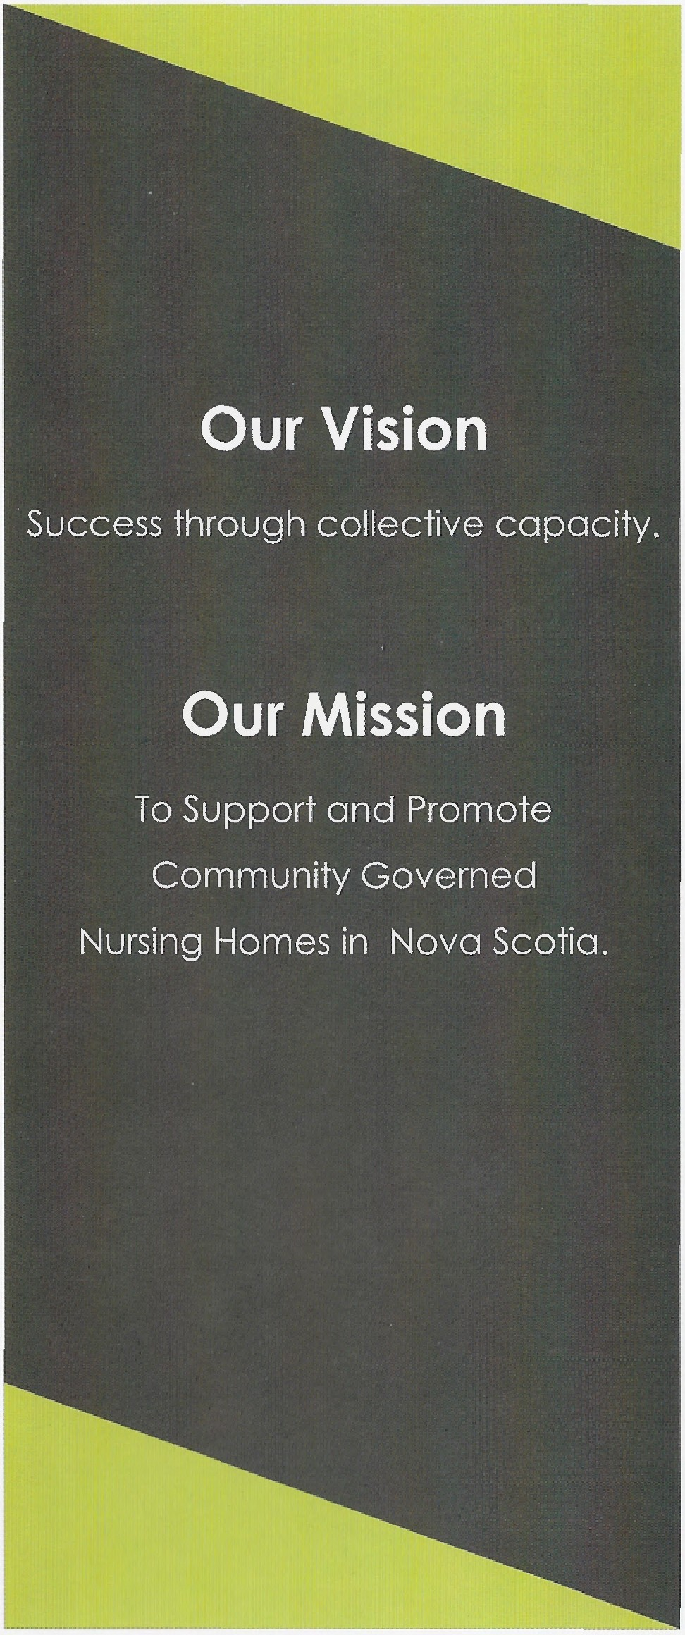

Community Governed

Community Governed Nursing Home Association of Nova Scotia
Nursing Home Association of Nova Scotia

PO Box 48044, Mill Cove PO
965 Bedford Highway
Bedford, NS B4A 3Z2
E-mail: cgons.info@gmail.com Website: www.cgons.ca
October 2017

The Community Governed Nursing Home Society of Nova Scotia, commonly referred to as “CGO” is a non-profit society founded in 2011 to support Nursing Homes in Nova Scotia that are community governed (Traditionally referred to as Non-Profit).

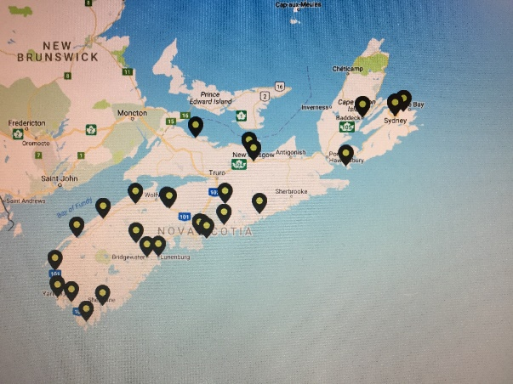

CGO represents 29 organizations and over 80%
of the 'non-profit' beds in Nova Scotia.

Alderwood Bayside Home
Braeside Nursing Home Dykeland Lodge
East Cumberland Lodge
Glen Haven Manor Grandview Manor Harbour View Haven
Harbourview Lodge
Hillside Pines Maritime Odd Fellows Home
Mountain Lea Lodge
Nakile Home for Special Care
Northwood Care Group of Companies Oakwood Terrace
Ocean View Continuing Care Centre
R.C. Macgillivary Guest Home
Rosedale Home for Special Care Roseway Manor
Saint Vincent's Nursing Home
St. Anne Centre
Seaview Manor
The Birches
The Cove Guest Home
The Meadows
Tideview Terrace Villa Acadienne
Villa Saint-Joseph du Lac
Windsor Elms Village

- Provide networking opportunities for Governors of Community Governed Organizations to learn and grow together in the provision of Long-Term Nursing Home Care in Nova Scotia.

- Provide opportunities for management and leadership of Nova Scotia's Com­ munity Governed Organizations to network with peers facing common challenges and to share best practices.
About Us
Member Organizations
CGO Objectives

- Provide a forum for organizations to build capacity among organizations of similar governance models.

- Increase the aptitude and confidence of both Board and Management structures through the sharing of risk. quality, ethical, and financial management best practices.

- Increase the understanding of the uniqueness of the Community Governed organization model and sup­ port member organizations in the delivery of safe, efficient and effective quality care and services.

- Advocate for the residents and staff within the Nova Scotia Nursing Home System.

