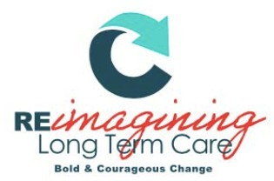

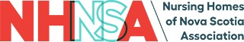

BETTER TOGETHER AWARD NOMINATION FORM

The Better Together Award
The Better Together award is in recognition of an individual or team who have prioritized inter-professional and community collaboration with the goal of increasing quality of care through meaningful and sustainable relationships and shared knowledge.

Eligibility: Any individual or group comprised of long-term care employees, contractors, healthcare providers, or volunteers may be nominated. (This includes and is not limited to: managers, executives, physicians, nurses, CCA’s, recreational therapists, occupational therapists, music therapists, physiotherapists, researchers, and/or volunteers.)

Process: Any employee, contractor, healthcare provider, or volunteer may nominate. Recipients will be selected on the basis of evidence provided by completion of the nomination eligibility criteria.

Award: Award winners will be announced October 26, 2022 at the NHNSA Awards Gala

Instructions: Please complete all prompts. Answer each question completely, providing specific examples or descriptions as requested. When possible, provide quantitative data to support examples. If you require more space, attach a sheet to the nomination form.
Please submit nomination form to admin@nhnsa.ca by September 27, 2022

BETTER TOGETHER AWARD NOMINATION FORM

Nominee(s):

Role(s):

Facility/Facilities:

Nominator (Your Name):

Nominator Email:

- Provide details regarding the project(s), initiative(s) or practice(s) that demonstrate inter-professional or community collaboration and relationship building. (This includes and is not limited to goals, involved parties, etc.)

- Discuss the impacts of the abovementioned project(s), initiative(s) or practice(s) on quality of client care and/or the advancement of the sector.

- Discuss the ways in which this collaboration is sustainable, long-lasting and/or contributed to a body of shared knowledge within the sector.

Date Submitted:

Please submit completed nomination form to: admin@nhnsa.ca

To be completed by NHNSA admin only:

Nominee Accepted?
Yes No
Date Accepted:

