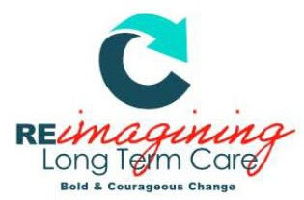

CHAMPION FOR DIGNITY AWARD NOMINATION FORM

The Champion for Dignity Award
Conference Logo
The Champion for Dignity award is in honour of the outstanding advocates for quality long-term care in Nova Scotia. Through passion and assertive influence, recipient(s) of this award have effectively and sustainably increased respect, investments, and overall growth in the sector.

Eligibility: | Any individual or group who fulfill the nomination criteria may be nominated. (This includes and is not limited to: managers, executives, physicians, nurses, CCA’s, recreational therapists, occupational therapists, music therapists, physiotherapists, researchers, families, residents and/or volunteers.)
Process: | Any employee, contractor, healthcare provider, or volunteer may nominate. Recipients will be selected on the basis of evidence provided by completion of the nomination eligibility criteria.
Award: | Award winners will be announced October 26, 2022 at the NHNSA Awards Gala
Instructions: | Please complete all prompts. Answer each question completely, providing specific examples or descriptions as requested. When possible, provide quantitative data to support examples. If you require more space, attach a sheet to the nomination form.  Please submit nomination form to admin@nhnsa.ca by September 27, 2022

1

CHAMPION FOR DIGNITY AWARD NOMINATION FORM

Nominee(s):

Role(s):

Facility/Facilities:

Nominator (Your Name):

Nominator Email:

- Provide details regarding how the nominee(s) have identified an opportunity requiring advocacy for improved resident care, team engagement/retention or system betterment.
– Discuss the specific roles and responsibilities of the nominee(s)

- Provide details regarding how the nominees clearly communicated the desired change and rallied support.

- Discuss the results and impacts of the advocacy efforts (Include details regarding the scale/scope, longevity, etc.)

Date Submitted:

Please submit completed nomination form to: admin@nhnsa.ca

To be completed by NHNSA admin only:
Nominee Accepted?
Yes No
Date Accepted:

