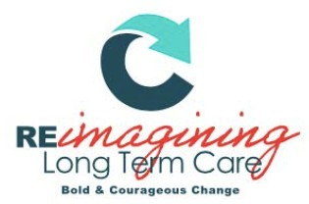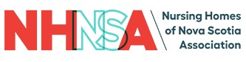

CULTURAL HARMONY AWARD NOMINATION FORM

The Cultural Harmony Award
Conference Logo
This award is a celebration of the efforts made to reimagine long term care in Nova Scotia as an increasingly equitable, representative, and inclusive community. The recipient(s) of this award have taken initiative in promoting and implementing sustainable and intersectional frameworks for diversity and inclusion within the sector.

Eligibility: Any individual or group comprised of long-term care employees, contractors, healthcare providers, or volunteers may be nominated. (This includes and is not limited to: managers, executives, physicians, nurses, CCA’s, recreational therapists, occupational therapists, music therapists, physiotherapists, researchers, and/or volunteers.)

Process: Any employee, contractor, healthcare provider, or volunteer may nominate. Recipients will be selected on the basis of evidence provided by completion of the nomination eligibility criteria.

Award: Award winners will be announced October 26, 2022 at the NHNSA Annual Awards Gala

Instructions: Please complete all prompts. Answer each question completely, providing specific examples or descriptions as requested. When possible, provide quantitative data to support examples. If you require more space, attach a sheet to the nomination form.

Please submit nomination form to admin@nhnsa.ca by September 27, 2022

CULTURAL HARMONY AWARD NOMINATION FORM

Nominee(s):

Role(s):

Facility/Facilities:

Nominator (Your Name):

Nominator Email:

- Provide specific examples of how this person/team has prioritized diversity, inclusion, and equity in the sector. This can include but is not limited to:
  - How this person/team has enriched and improved the environment for care partners,
  - How this person/team has enriched and improved the quality of care and/or life for their clients,
  - And/or how this person/team has enriched and improved their connections to their community.

Describe how this person/team has emphasized a sustainable and long-lasting approach to diversity.

Date Submitted:

Please submit completed nomination form to: admin@nhnsa.ca

To be completed by NHNSA admin only:
Nominee Accepted?
Yes No
Date Accepted:

