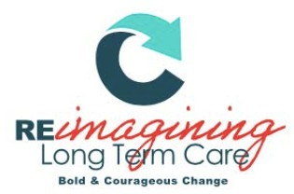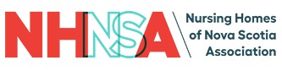

LEADING THE WAY AWARD NOMINATION FORM

The Leading the Way Award
Conference Logo
The Leading the Way award is in recognition of the incredible, engaging and passionate leaders in long term care. The recipient of this award is actively creating a legacy of impacting the system. This person consistently inspires a shared vision, leads with authenticity, and proactively engages in conversations to protect, sustain, and better the highest standards for best practice in long term care in Nova Scotia.

Eligibility: Any individual long-term care employee, contractor, healthcare provider, or volunteer may be nominated. (This includes and is not limited to: managers, executives, physicians, nurses, CCA’s, recreational therapists, occupational therapists, music therapists, physiotherapists, researchers, and/or volunteers.)

Process: Any employee, contractor, healthcare provider, or volunteer may nominate. Recipients will be selected on the basis of evidence provided by completion of the nomination eligibility criteria.

Award: Award winners will be announced October 26, 2022 at the NHNSA Annual Awards Gala

Instructions: Please complete all prompts. Answer each question completely, providing specific examples or descriptions as requested. When possible, provide quantitative data to support examples. If you require more space, attach a sheet to the nomination form.
Please submit nomination form to admin@nhnsa.ca by September 27, 2022

LEADING THE WAY AWARD NOMINATION FORM

Nominee(s):

Role(s):

Facility/Facilities:

Nominator (Your Name):

Nominator Email:

- Discuss the roles and responsibilities of this leader:

- Provide specific examples of this person’s commitment to effective, inspiring and sustainable leadership:
  - What leadership skills do they possess and regularly use? Please be specific, including examples of how these skills have been displayed.

  - Detail how they have specifically impacted their team, residents, or community.

Date Submitted:

Please submit completed nomination form to: admin@nhnsa.ca

To be completed by NHNSA admin only:
Nominee Accepted?
Yes No
Date Accepted:

