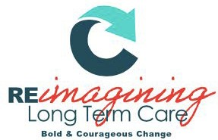

SPIRIT AWARD NOMINATION FORM

The Spirit Award
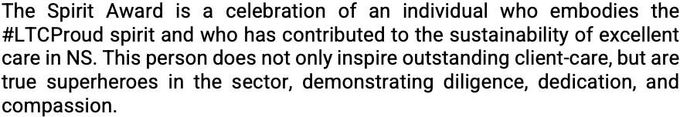

Eligibility: Any person working in long-term care in a non-management role
in Nova Scotia.

Process: Any employee, contractor, healthcare provider, or volunteer may nominate. Recipients will be selected on the basis of evidence provided by completion of the nomination eligibility criteria.

Award: Award winners will be announced October 26, 2022 at the NHNSA Awards Gala

Instructions: Please complete all prompts. Answer each question completely, providing specific examples or descriptions as requested. When possible, provide quantitative data to support examples. If you require more space, attach a sheet to the nomination form.
Please submit nomination form to admin@nhnsa.ca by September 27, 2022.

SPIRIT AWARD NOMINATION FORM

Nominee(s):

Role(s):

Facility/Facilities:

Nominator (Your Name):

Nominator Email:

- Provide specific examples of how this person has met the criteria:
  - How do they demonstrate inspiring, excellent client-care?

  - How do they demonstrate pride in long-term care?

- Describe the impact this person has on their clients, co-workers, and community.

Date Submitted:

Please submit completed nomination form to: admin@nhnsa.ca

To be completed by NHNSA admin only:
Nominee Accepted?
Yes No
Date Accepted:

